Public Community Profile

Users  - Primary  - Community manager  - Secondary  - Visitors | Phase 1
Intended Outcome
- Organizers create their community profile as they want to introduce their communities to outsiders and prospective members.
- Visitors interact with community they select as they are served with community profile
Links
- …
- …
- …
- …
- …

Introduction
One of the community organizers we invited to try Kolavo ended up leaving after registration and saying that he wanted to see communities in it before creating his own. This seems he did not have the motivation of creating his community profile because he did not know what it would look like. Therefore, we want to motivate community organizers to create their community profiles by introducing communities through profiles to the public.

In addition to that, people who are invited to try Kolavo directly leave as soon as they see the current default page: login page. It seems they did not have the appetite to browse around since there is no interesting information they can find. Therefore, we want to increase their attention to the Kolavo app by sharing community profiles.

Product Requirement
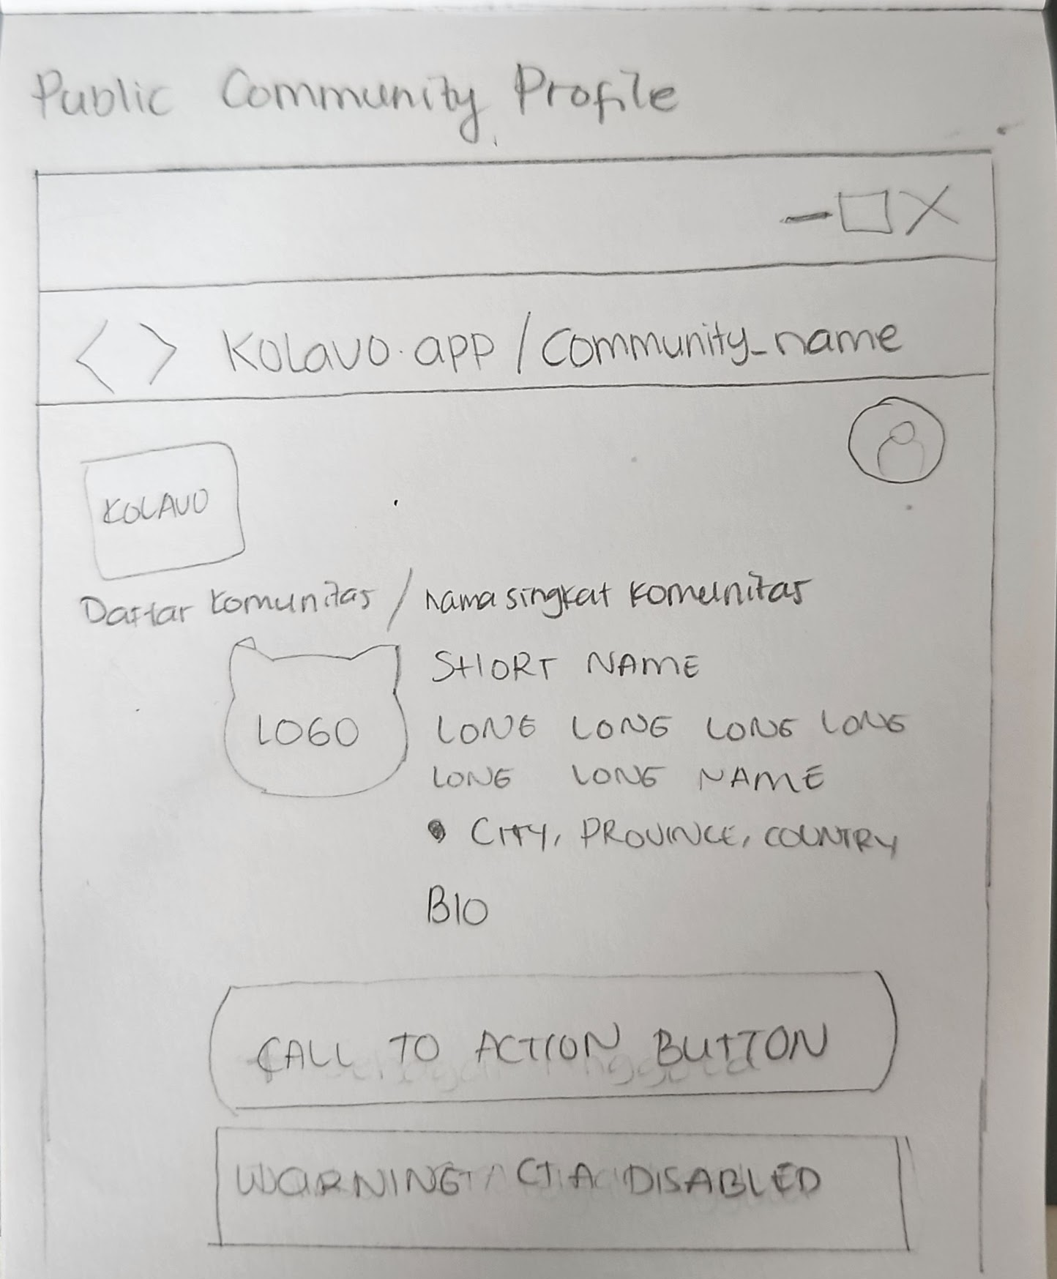
Sketch

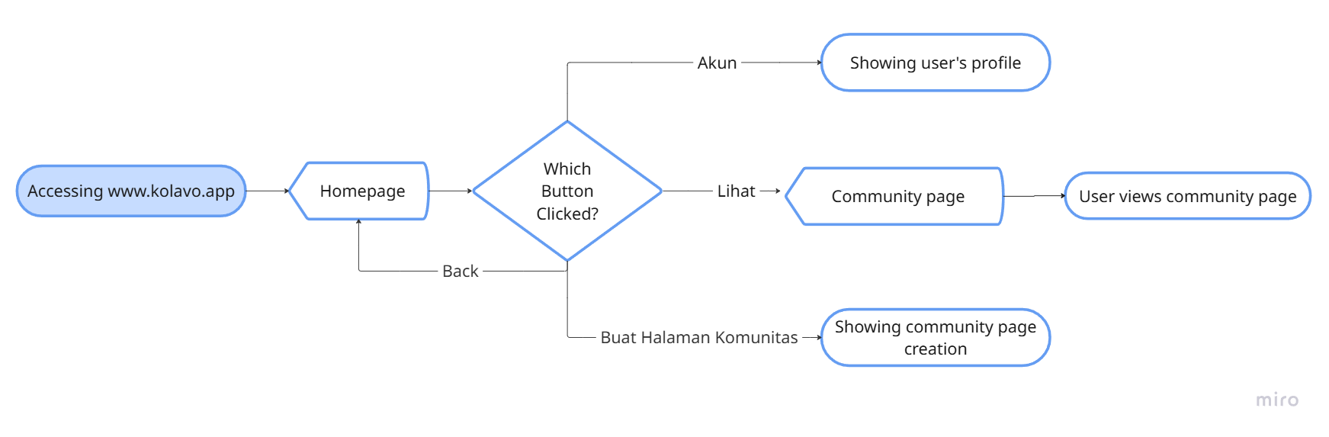
Flow of Viewing Community Page

No | User story | Scope | Acceptance Criteria
1 | As community managers, I want to know what community information will be further shown, so I can prepare the data. | Community profile visible to non registered users | - Community profile is shown after clicking it in the homepage
1 |  | Community profile is shown in community page | - Community profile is the first section in community page  - Community page background color theme is adjusted as set by community manager  - Information including:  - Logo  - Long name  - Domicile  - Bio
2 | As community managers, I want to see community identity at glance, so I know what community I look at. | Community page header | - Community page header is used whenever the system shows community related content.  - Community page header shows [community abbreviation]
3 | As community managers, I want to know how Kolavo could help us collect our member data, so we can decide whether or not it is helpful. | Call to action is part of community profile | - CTA is close to community profile  - Different state show on CTA based on membership status
4 | As community organizers, I want to see other community profiles listed in community directory | Way to return to community list | - In pc, outside community profile area, show clickable breadcrumbs  - Start with community list then slash community short name  - For mobile, give back button to give sign
5 | As a user who skipped onboarding and did not update my profile, I want to be reminded why I couldn’t register to a community, so I can follow the right steps. | Blocker modal | - Modal shows only to users who want to join community by clicking join button at the community profile but did not update their profile  - The modal explain friendly why and encourage users to update by also giving a button to edit profile page  - The modal also give another option to skip updating profile which will close the modal and stays in current page

Design Requirement

Community Header
Design Intent | To increase visitor’s awareness where they are at and ease them to return to previous page
Content / Copy | - < [community abbreviation]  - In PC version: Komunitas > [community abbreviation]
Visual Requirement | - < and Komunitas using community theme color
Interaction Behavior | - Mobile: When click <, redirect to community list  - PC: Clicking Komunitas redirects to community list
Acceptance Criteria

Community Profile
Design Intent | The logo and profile information should feel like one cohesive identity block, similar to a profile layout rather than a document header.
Content / Copy | Includes:  - community logo  - Fullname: [community fullname]  - Domicile: [country flag] [city], [province] if filled  - Bio: [bio] if filled  - CTA based on state:  - Not member yet: Gabung  - Applied but not yet accepted: Pendaftaran Sedang di Proses  - Applied but rejected: Pendaftaran Belum Diterima  - Helper: Saat ini kamu belum bisa mengajukan ulang pendaftaran.  - Member: button not shown
Visual Requirement | - Logo shape place is rounded square  - At the pc version, profile layout looks tidy and compact at the middle like profile in instagram.
Interaction Behavior | - When logo is not uploaded, use first initial letter looking matching with community theme color  - CTA acts based on states  - If the Gabung Komunitas button is clicked, showing the registration form.  - Menunggu Persetujuan is not clickable
Acceptance Criteria
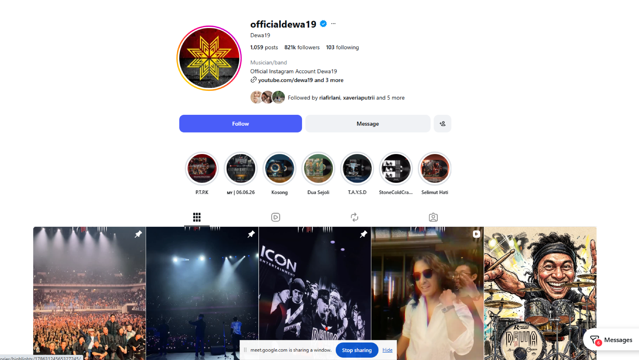
Profile at Instagram

Blocker Modal
Design Intent | Educate users that updating profile is required and guiding them to access the update profile page
Content / Copy | - Illustration: not known illustration  - Modal title: Kamu belum dikenali  - Body: Lengkapi profil mu agar kamu bisa dikenali dan bergabung komunitas di Kolavo.  - Update profile button: Perbarui Profil  - Skip button: Nanti saja
Visual Requirement
Interaction Behavior | - Opens update profile page when Update profile button is clicked  - Close the modal when skip button is clicked
Acceptance Criteria

Engineering Requirement

Questions

